VOLUNTEER APPLICATION

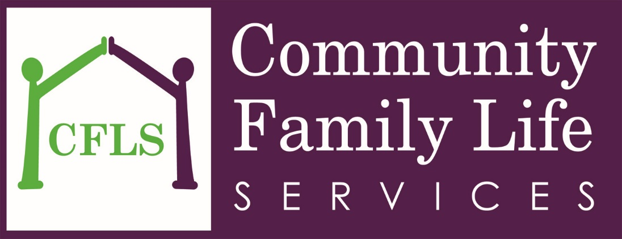

Community Family Life Services
Volunteers play an important role within Community Family Life Services. Volunteer duties range from helping in our Clothing Closet to assisting at one of our many events. Volunteers at CFLS are treasured assets, and a vital factor in meeting our mission to provide homeless adults, families, and women’s reentry with the tools and support they need to reconnect with their families and live life to their full potential. Anyone interested in becoming a volunteer with Community Family Life Services will be required to complete this volunteer application. All volunteers are asked to show proof of identification.

VOLUNTEERING HOURS
Volunteering is available during the following hours:
• Monday – Friday from 10:00 am to 4:00 pm
• Weekend hours available for special events

RECORD KEEPING
For your/our record keeping, new volunteers will be required to maintain accurate records of hours volunteered on a daily basis on forms provided by the Department. It is the responsibility of each volunteer to sign in on the volunteer log kept in the front office.

MEDIA CONTACT
Volunteers may not provide comment to the media pertaining to activities at the Department. All volunteers are asked to sign an Image and Interview Release Form.

TERMINATION
This is a mutual agreement and each person may opt to terminate this agreement at any time. The staff volunteer coordinator has the authority to terminate any volunteer from activities within the Department.

Volunteer ApplicatioN
Note: All information in this application will be kept strictly confidential, and shall be used only in the management
of the services and programs provided by Community Family Life Services.

Date _______________________

First Name ___________________________ Last Name _____________________________________
Address______________________________________________________________________________
City __________________________________ State ___________ Zip Code _________________
Email __________________________________ Cell Phone __________________________________
Work Phone _____________________________ Best way to reach me: Email Cell Work
Occupation _______________________________ Employer ___________________________________
Emergency Contact ________________________ Phone Number _______________________________

Please indicate the day(s) and time(s) you would generally be available to volunteer your services:
 | Mornings  (9 am – 12 pm) | Afternoons  (12 pm – 5 pm)
Monday
Tuesday
Wednesday
Thursday
Friday

PERSONAL STATEMENT: By signing this volunteer application, I certify the information I have provided is true and complete. I understand that any misrepresentation, willful emission, false or misleading information may disqualify me from further consideration for volunteering, or may result in my removal as a volunteer at Community Family Life Services. I understand that I must abide by all policies, rules, and regulations of CFLS.

Signature |  |  | Date
Parent / Guardian signature (if under18)_ |  |  | Date

If completing this form online, please email it to Erin Calloway, Director of Community Initiatives, at ecalloway@cflsdc.org. For more information, call (202) 733-3010 ext. 4176.

Image and Interview Rights Release

I hereby give COMMUNITY FAMILY LIFE SERVICES the absolute and irrevocable right and permission to use, adapt, modify, reproduce, distribute, and publicly display my image or likeness in whole or in part.

I further hold COMMUNITY FAMILY LIFE SERVICES harmless from any and all actions that may occur from the use, adaptation, modification, reproduction, distribution, and public
display of my image or likeness in whole or in part, individually or in conjunction with other materials, in a n y medium now known or later developed, and for any purpose whatsoever, including but not limited to printed or electronic fundraising materials.

I hereby release, waive and discharge COMMUNITY FAMILY LIFE SERVICES and its Board of Directors from any and all demands for consideration or claims that I have or may have arising out of or in connection with the foregoing use of my image or likeness and/or that of my minor child , including but not limited to any claims or invasion of privacy, defamation, infringement of my right of publicity, copyright infringement, or any other cause of action arising out of the use, adaptation, reproduction, distribution, broadcast or exhibition of my image or likeness and/or that of my minor child.

I warrant and represent that I am at least 18 years old and have the authority to grant the foregoing permission and release.

I understand, acknowledge, and agree that you shall have the sole and exclusive right to all
original works that use or otherwise incorporate my image or likeness and/or that of my minor
child, including but not limited to all copyrights.

_____________________ __________________________________
Date Name (Print)

_____________________ __________________________________
Date Signature

_____________________ __________________________________
Witness Print Name Witness Signature

__________________________________________________________
This document effectively releases Community Family Life Services from any liability resulting from copyright infringement or infringement on other rights committed by signer of this release.

Volunteer Waiver

I would like to volunteer my services to the Community Family Life Services with no expectation of being paid any compensation for such services. I am responsible for my actions and I, __________________________ hereby release Community Family Life Services from any and all liability, demands or claims for loss or damage of any kind resulting in any injury due to my service to the community.

_____________________ __________________________________
Date Name (Print)

__________________________________
Signature

_____________________ __________________________________
Witness Print Name Witness Signature

The following questions are used only for demographic purposes in order to chart volunteer trends. Answering is voluntary.

Date of Birth: _________________________ Male Female

Race:
African-American Caucasian Latino Asian African Other

Are you a client of CFLS? No Yes If so, which program?

How did you hear about volunteering at Community Family Life Services?

Do you have any limitations that would affect your mobility, communication, or ability to perform certain tasks? No Yes If so, please explain

How many hours/week would you have available to volunteer? _________________________

Please list a few of your hobbies, interests, and activities. Highlight any special skills you can offer as a volunteer.

What made you want to volunteer with Community Family Life Services?

Please check off volunteer positions in which you are interested.

- Adult Mentor  - Food Volunteer  - Clothing Volunteer  - Group Projects  - Maintenance | - Administrative / General Clerical  - Data Entry  - Desktop Publishing /Word Processing  - Special Events  - Fundraising  - Photography / Video

